**Contractor’s user guide**

## Welcome Screen

The system is available to all PDO Contractors by clicking on the link  [http://web.pdo.co.om/CEHD/](%20http://web.pdo.co.om/CEHD/). The welcome screen shown below is presented.

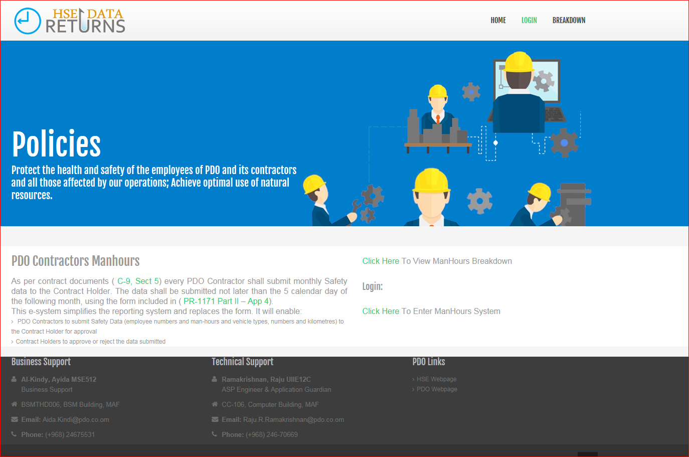

## Login Screen

Click on the **Login** link to go to the login screen. Or Click here To enter Man-hours system

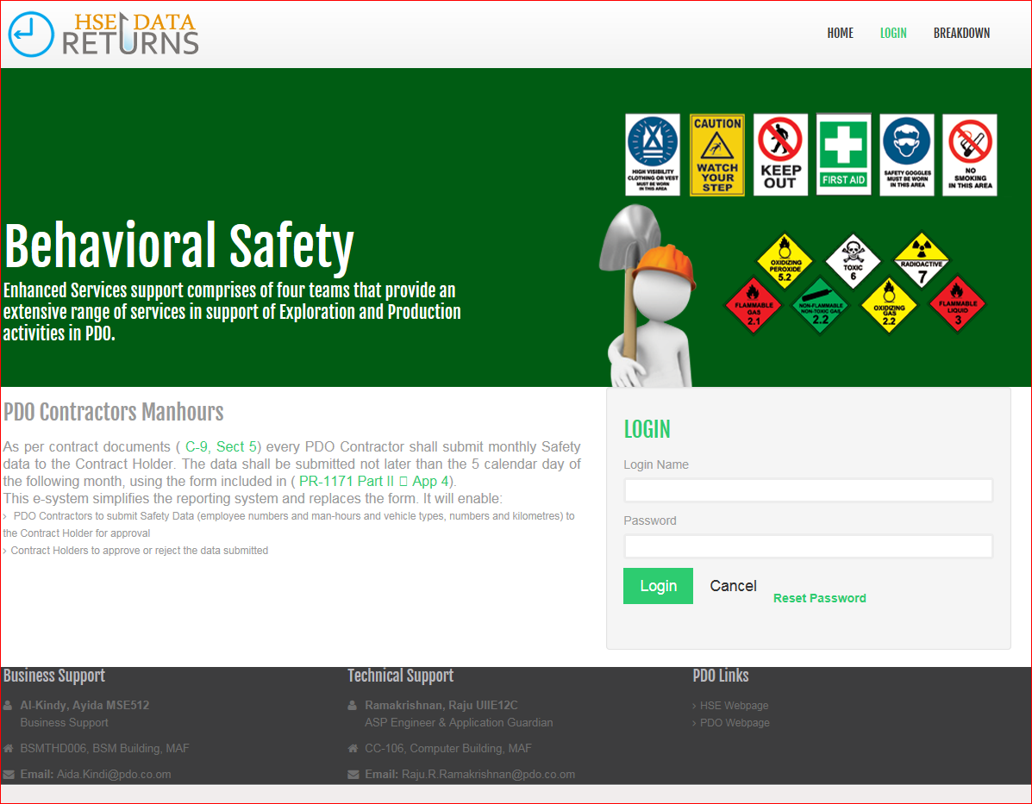

Enter your **username** and **password.** Contact MSE/4211(<mailto:Aida.Kindi@pdo.co.om>) or the Contract Holder (CH) for your username and password.

If successful, you will be presented with the logged-on screen.

**Reset Password**

If you forgot your password you can use the reset password option in the login screen as highlighted in the below screen as yellow.

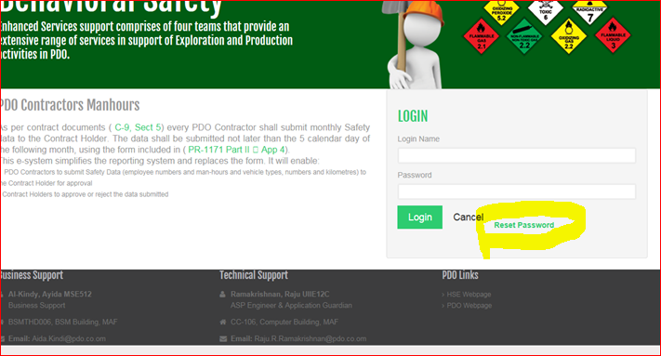

If you click the reset password link below screen will open for the reset password.

You have give your contract no and user name as a input to the below screen then click the reset button to reset the password you will get email notifications with the login details

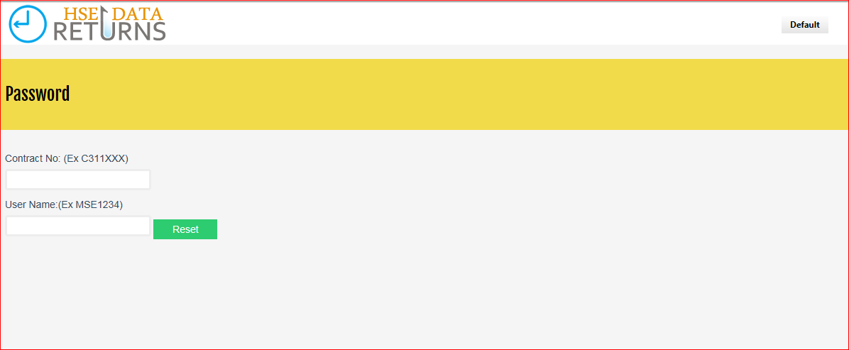

**Change Password**

After reset the password if you login with new credentials, the screen will taken to you change password screen to change the password. Below is the screen shot for the Change password screen.

You have to provide the old password and new password, confirm password details and submit, your new password will be effect for the next login attempt.

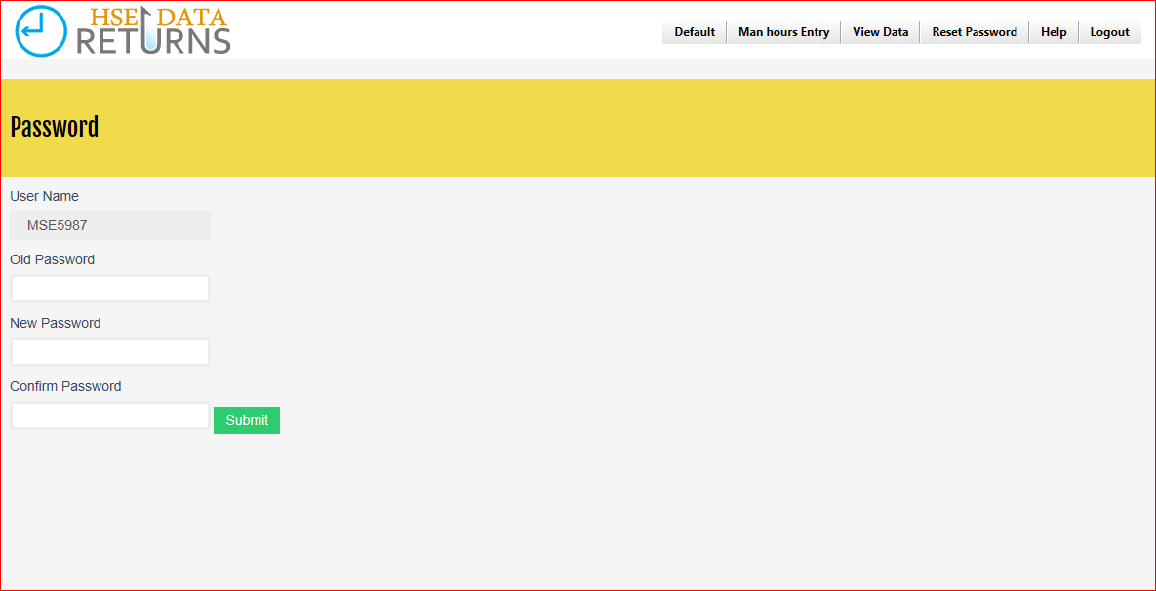

## Data Entry

On successful logon, click the Data Entry menu to reveal the following screen.

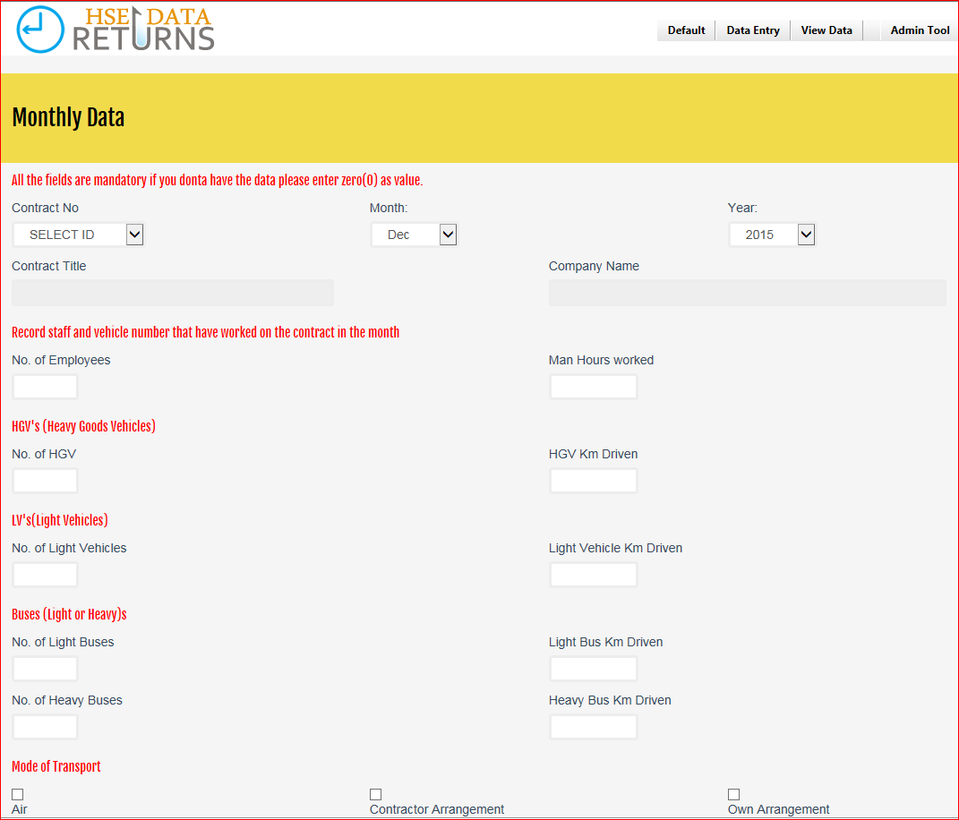

Contractors are required to enter the following data for the month viz.:

* Man-hour Data
* Km-Driven Data
* Names of Employees absent from work during the month due to LTI or RWC (if any)
* Return dates of previously injured employees who returned to work during the month (if any)

When finished, click the **Submit** button. This will result in the following actions:

* 1. An email is automatically sent from you to the contract holder in PDO notifying him of your submission.
  2. A copy of this email is sent to you for your records.
  3. If your data submission is approved by the Contract Holder, an email is sent to you informing you of the approval.
  4. If the data is rejected, an email is sent to you by the CH informing you that the data has been rejected including the reason for rejection. You are then expected to check and update the data accordingly by clicking on the URL link contained in the email from the CH.

***(Note you can also update/correct the data by logging on to the system and clicking on View Data | Rejected Data menu and then correct the data)***

You can then exit the system by clicking on Logout

## View Data

You can view the data you have previously entered by clicking on the View Data menu. This menu option will enable you to review the following data:

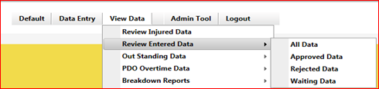

* ***All Data*** – view **ALL** data previously submitted by you to the Contract Holder
* ***Approved Data*** – view data submitted by you and which have been approved by the Contract Holder
* ***Rejected Data*** – view data submitted by you but which were rejected by the Contract Holder
* ***Waiting Data*** – view data submitted by you which are awaiting the approval of the Contract Holder.

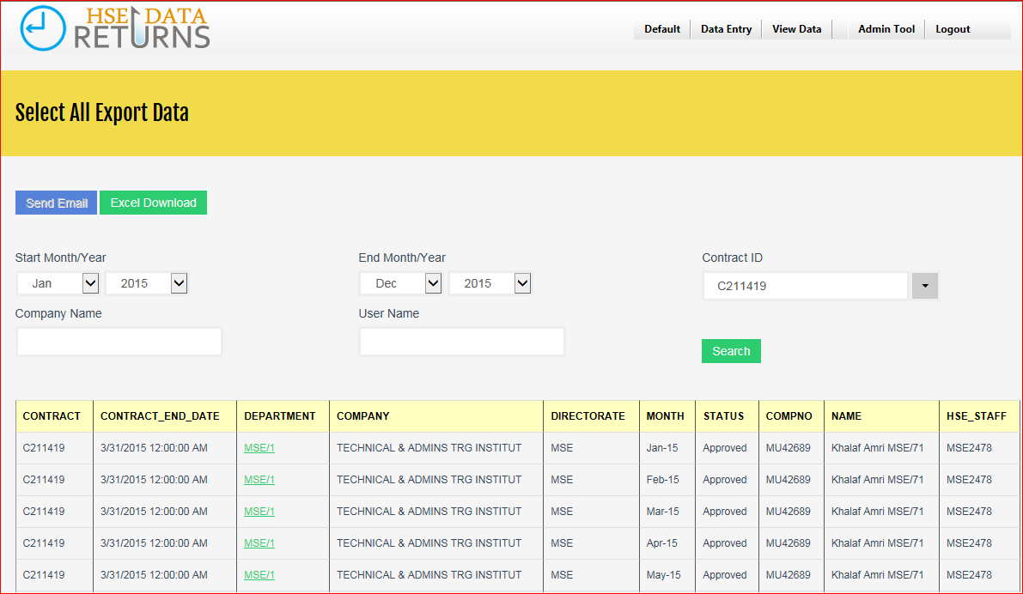

You can access a particular month’s data by clicking on the link for that particular month (01-Jan-2004). This will open up a new window with details of your submission for that month displayed. You can print the data from this window if you wish.

Note that you are only permitted to change data which have been rejected by the CH. You will not be able to change any **Approved** or **Waiting** data.

## Download to Excel

You can download the data you have previously entered into Microsoft Excel by clicking on the Excel Download Button.

You can chose to download data for a particular contract or for all contracts held by you with PDO. You can also view and/or print a particular month’s data before download by clicking on the link for that particular month (**01-Jan-2004**). This will open up a new window with details of your submission for that month displayed.

**Contract Holder user guide**

## Accessing the System via E-mail Link

The Contract Holder, CH, will normally access the system via a URL link contained in an email sent from the contractor notifying him of the submission of the monthly HSE data. A sample of the email with the URL link is shown below

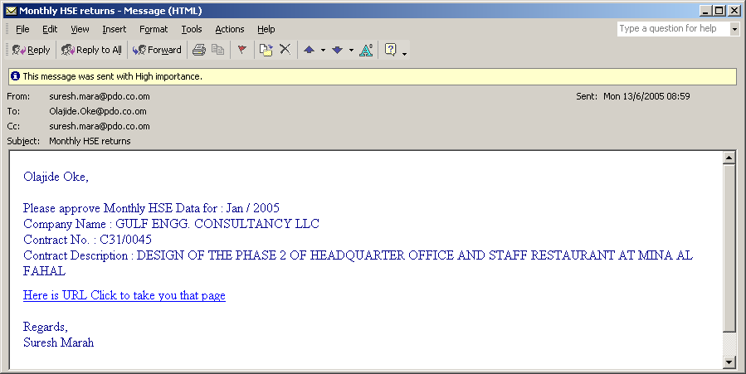

If you click on the link, you will be presented with the following screen which contains details of the monthly HSE data for the month.

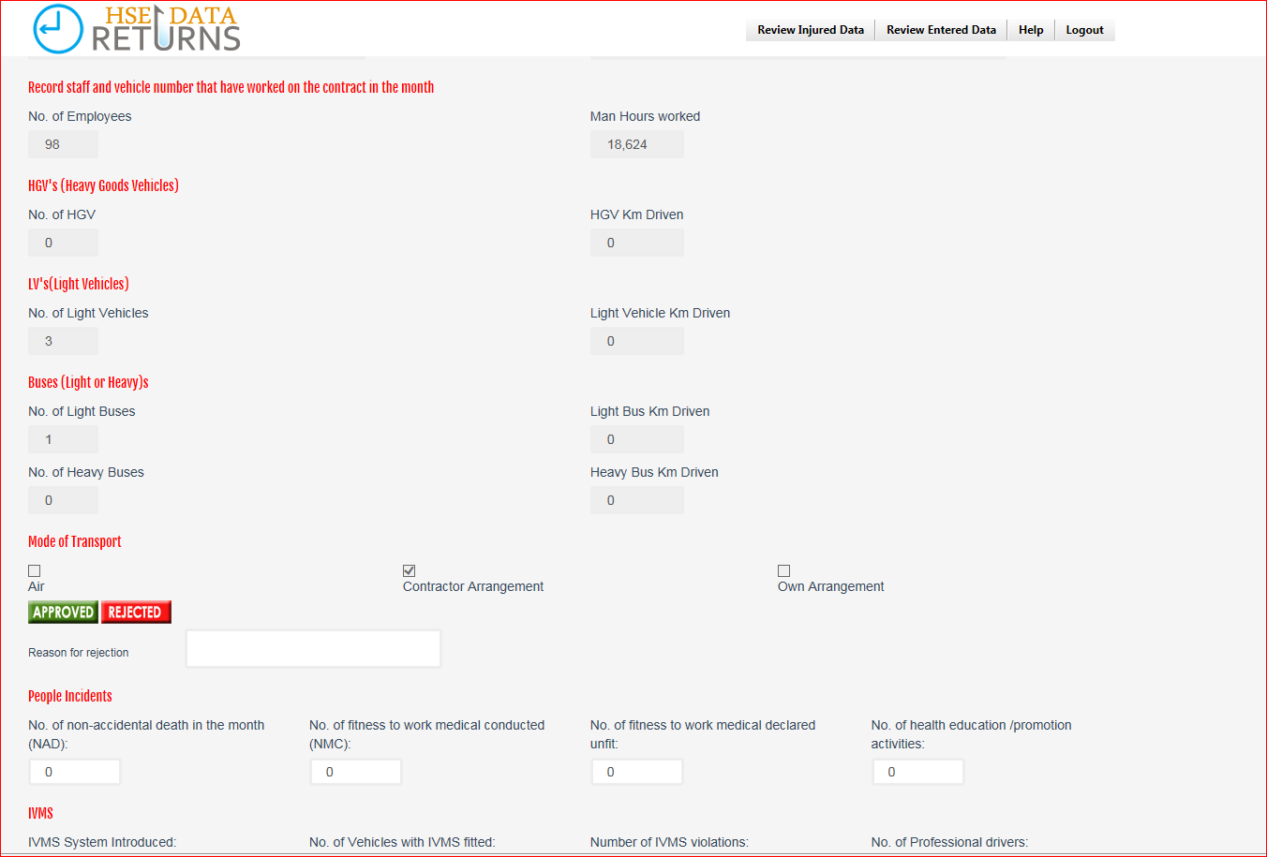

## Accepting or Rejecting Submissions

The CH is expected to review the data submitted and either **accept** or **reject** the data. The followings are the chain of events:

***Acceptance***

* To accept the data, click on the ACCEPT button.
* An email is sent from you to the Contractor informing him that his submission for that month has been accepted.
* A copy of the email is sent to you for your records.

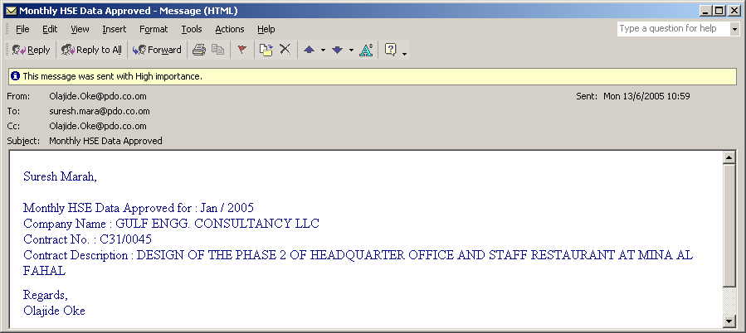

***Rejection***

* To reject the data, enter in the space provided a reason for the rejection
* Click on the REJECT button.
* An email is sent from you to the Contractor informing him that his submission for that month has been rejected together with the rejection reason.
* A copy of the email is sent to you for your records.

## 

## Rejected Submissions

The Contractor is notified of the rejection of its submission via an email from the CH. The Contractor is then expected to make changes to the data and re-submit again for approval by the CH. The revised submission can then either be accepted or rejected and the cycle is repeated again. This process will continue until the data is accepted by the Contract Holder.

## Accessing the System via Welcome Screen

The Contract Holder can also the system for the purposes of viewing or printing data previously submitted by the contractor by clicking on the link [http://mus-ws-200/CEHD/](http://mus-ws-200/CEHD/default.asp) . The welcome screen shown below is presented:

**Administrator user guide**



Clicking on the **Click Here To enter Manhours System** link of the welcome screen takes you straight to the system. Passwords are not required for CHs to logon to the system as they are automatically recognised from their Windows logon identity.

## View Data

You can view the data previously submitted by your contractors by clicking on the View Data menu. This is limited **only** to contracts for which you are the CH. You will not be able to view submissions for other contractors. This menu option will enable you to review the following data:

* ***All Data*** – view **ALL** data previously submitted by the Contractor
* ***Approved Data*** – view data submitted by the contractor and which have been approved by the Contract Holder
* ***Rejected Data*** – view data submitted by the contractor but which were rejected by the Contract Holder
* ***Waiting Data*** – view data submitted by the contractor which are awaiting the approval of the Contract Holder.

You can access a particular month’s data by clicking on the link for that particular month (e.g. 01-Jan-2004). This will open up a new window with details of your submission for that month displayed. You can print the data from this window if you wish.

You will be able to Approve or Reject any data with the status ***Waiting***.

## Welcome Screen

The system is available to all PDO Contractors by clicking on the link <http://web.pdo.co.om/CEHD/>. The welcome screen shown below is presented.



## Login Screen

Click on the **Login** link to go to the login screen. Or Click here To enter Man-hours system



Enter your **username** and **password.** Contact MSE/4211(<mailto:Aida.Kindi@pdo.co.om>) or the Contract Holder (CH) for your username and password.

If successful, you will be presented with the logged-on screen.

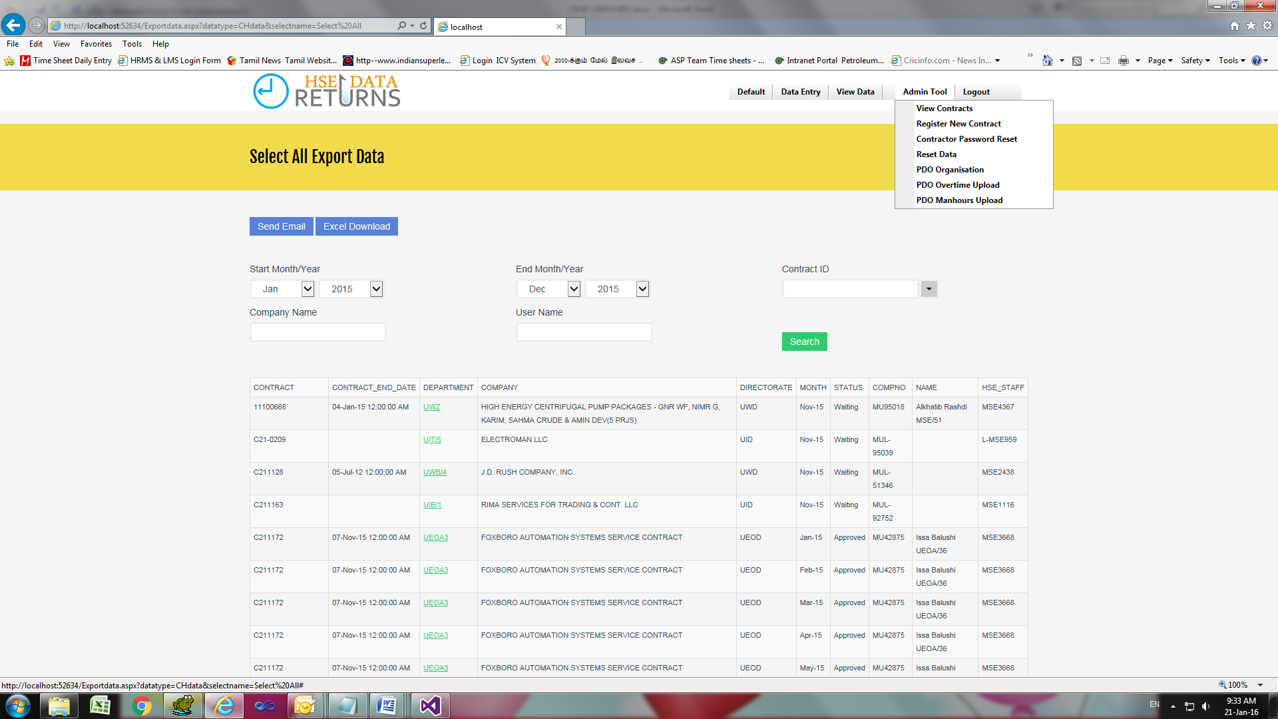

Admin can able to View Contracts, register new contracts.

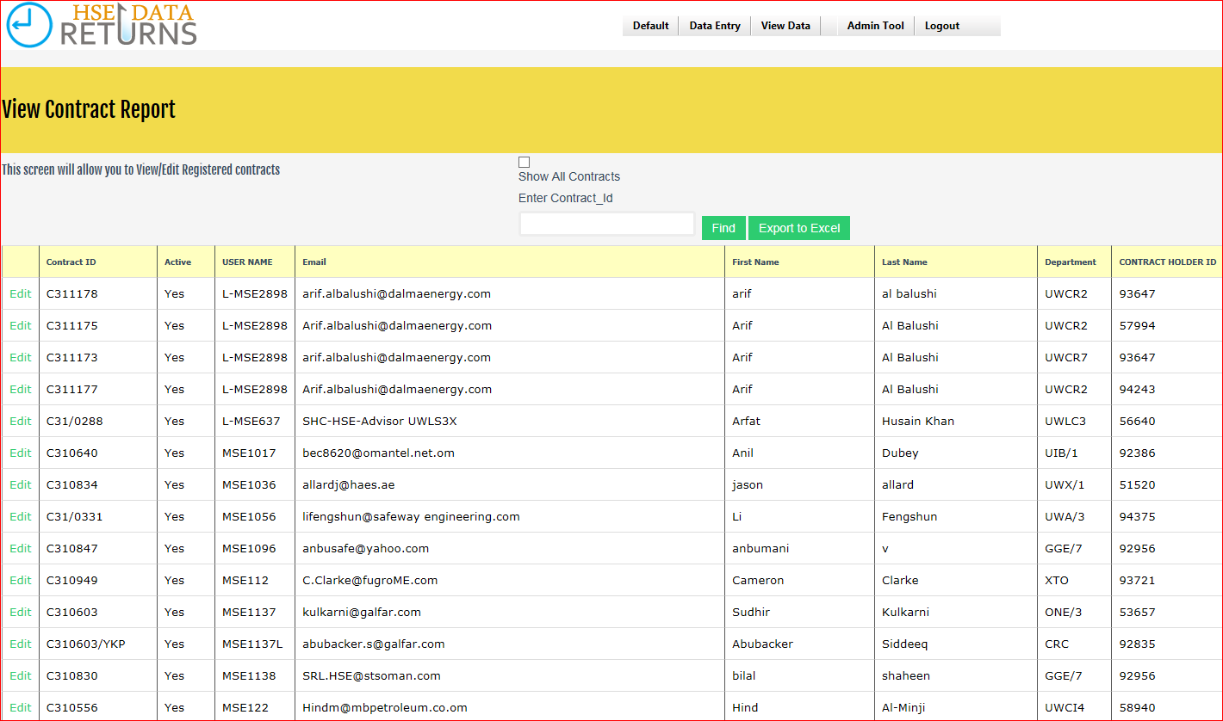

Register New Contract:

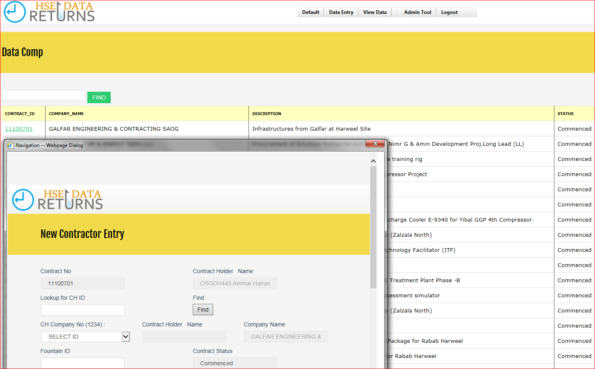

Admin PDO Overtime and man-hours data upload

Using the below screen Admin can able to upload the monthly PDO safety data returns data in to the system.

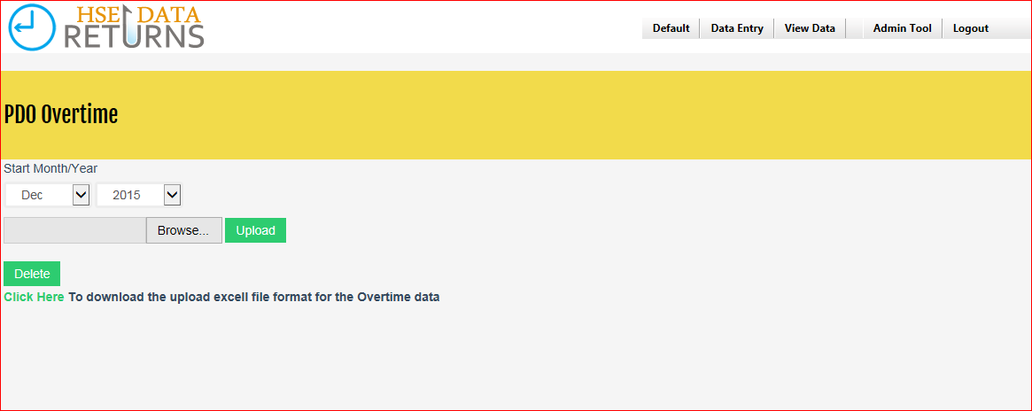

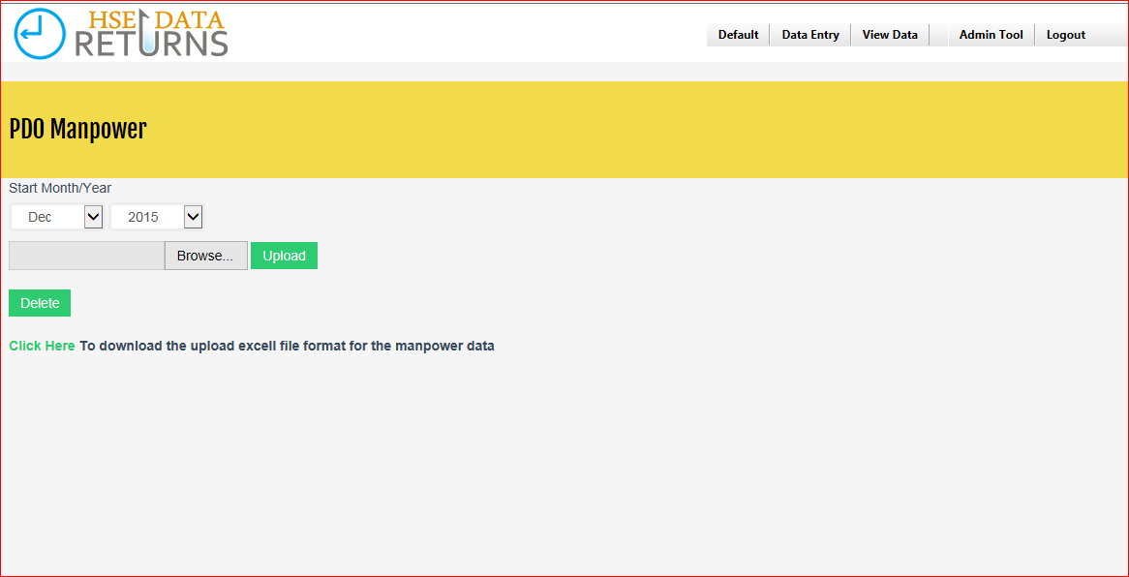

Admin can reset the data ,password and organization using the Admin tool menu.

## Data Entry

Admin can able to enter the contractor’s data using the Data entry menu.

For entering the contractors data admin can choose the contract no and month , year for entering the data.



Contractors are required to enter the following data for the month viz.:

* ManHour Data
* Km-Driven Data
* Names of Employees absent from work during the month due to LTI or RWC (if any)
* Return dates of previously injured employees who returned to work during the month (if any)

When finished, click the **Submit** button. This will result in the following actions:

* 1. An email is automatically sent from you to the contract holder in PDO notifying him of your submission.
  2. A copy of this email is sent to you for your records.
  3. If your data submission is approved by the Contract Holder, an email is sent to you informing you of the approval.
  4. If the data is rejected, an email is sent to you by the CH informing you that the data has been rejected including the reason for rejection. You are then expected to check and update the data accordingly by clicking on the URL link contained in the email from the CH.

***(Note you can also update/correct the data by logging on to the system and clicking on View Data | Rejected Data menu and then correct the data)***

## View Data, Send Email and Download to excel

You can view the data you have previously entered by clicking on the View Data menu. This menu option will enable you to review the following data:



* ***All Data*** – view **ALL** data previously submitted by you to the Contract Holder
* ***Approved Data*** – view data submitted by you and which have been approved by the Contract Holder
* ***Rejected Data*** – view data submitted by you but which were rejected by the Contract Holder
* ***Waiting Data*** – view data submitted by you which are awaiting the approval of the Contract Holder.



You can access a particular month’s data by clicking on the link for that particular month (01-Jan-2004). This will open up a new window with details of your submission for that month displayed. You can print the data from this window if you wish.

Note that you are only permitted to change data which have been rejected by the CH. You will not be able to change any **Approved** or **Waiting** data.

You can chose to download data for a particular contract or for all contracts held by you with PDO. You can also view and/or print a particular month’s data before download by clicking on the link for that particular month (**01-Jan-2004**). This will open up a new window with details of your submission for that month displayed.